AAPA Communications Award Program Entry Classification: Video

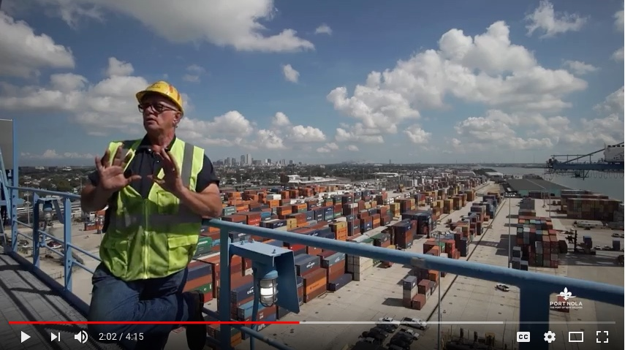
Port NOLA “Your Working River” Video

Summary — The Port of New Orleans Public Affairs team worked with a local video production firm to create a video that highlights the jobs and the hardworking men and women who work at the Port of New Orleans.

You can watch the video here or see the mp4 attached.

1. What are/were the entry’s specific communications challenges or opportunities?
The 2017 State of the Port was scheduled for November 2017. It was to be the first state of the Port address for Brandy D. Christian who was named Port NOLA President & CEO just about year prior after the retirement of her predecessor who had steered the course for more than 15 years. The President & CEO’s message included recent successes and a roadmap for moving forward with purpose, strategy and collaboration.
We wanted to close the State of the Port with an emotionally evocative video with the message that we are all in this together, and, in the end, it is the people of the industry who will make it work.
We also wanted to have an impactful collateral piece that highlights the port’s value as a job creator that could be used in the longer term across all our communication channels.
We had a short timeline to create this video and two others for State of the Port and a small budget—a month and half and $3,000 for all three videos.
2. How does the communication used in this entry complement the organization’s overall mission?
The Port of New Orleans mission is: To drive regional economic prosperity by maximizing the flow of international trade and commerce as a modern Gateway.
The “Your Working River” video features a variety of real Port NOLA workers - port employees and tenants - in their work environments talking about the value of their jobs and the industry. We want the community to recognize the Port as source of jobs and an economic engine, so that they are more likely to become ambassadors for our mission and support the Port when issues arise such as the funding of capital improvements or land use issues for potential port development.
3. What were the communications planning and programming components used for this entry?
Goals:
- To close out the 2017 State of the Port with a human-interest piece that evokes an emotional connection with the audience.
- To have an impactful collateral piece that could be relevant for up to two years across all our communications channels.
- To send a key message to the community and to policymakers that the Port is a job creator and an economic engine.
- To celebrate the hardworking men and women who make the port and maritime industry a success.
- To demonstrate to the industry audience that the Port supports a strong, skilled and diverse workforce.
- To demonstrate the diverse scope of careers available and the diversity of the people who work in the industry.

Measurables: We would measure the success of this video by audience response at various presentations throughout the year. Also through social media engagement analytics.

Primary Audiences: Community – residents of the three-parish jurisdiction, economic development organizations, state legislators, local governments, local media.
Secondary Audiences: Industry stakeholders - terminal operators, carriers, shippers, customers, potential customers, tenants, industry media, etc.

4. What actions were taken and what communication outputs were employed in this entry?
Strategies and tactics:
- Much thought went into what port jobs to feature. We wanted a variety including administrative, professional, longshoremen, maintenance, engineering, law enforcement etc. to demonstrate the variety of careers made possible by port activity.
- We chose speaking roles that would address four distinct angles: 1. longshoreman - the value of the river to family-supporting jobs, 2. Harbor Police – finding opportunity and an upward career path, 2. Crane maintenance – pride in what one does, 3. Truck driver – finding a career in one’s hometown, 4. Accounting specialist – the sense of family and love for her fellow Port employees.
- We also put much consideration toward representing the diverse ethnicity and age range of port workers to reflect the diverse demographics of our jurisdiction.
- We engaged port tenants and operators to be included in the video to extend their own marketing efforts.
- The video was limited to 4 minutes with compelling content to hold audience attention.

The Port NOLA communications team worked with local video production company Studio Vieux Carre to produce this video and two others for the State of the Port. We spent two weeks coordinating with each person to be featured and shooting adequate footage, and another week of editing and production.

5. What were the communications outcomes and what evaluation methods were used?
Anecdotal: Thousands of visitors to the Port have seen the “Your Working River” video as part of regular Port tours for industry and community. It has been shown at many of the President and CEO’s presentations since the State of the Port. It has been posted on our website as well as all our social media platforms.
Audiences connect immediately with the video and react enthusiastically, and many of our partners have inquired about how they can produce one like it. On one occasion, after a group of maritime and logistics students watched it, they asked if they could meet Ms. Nancy, the woman who closes out the video “with love in her heart.” Nancy happily came to meet them and it was as if they met a celebrity.

Metrics as of May 2018:
Port NOLA’s “Your Working River” (People) video was uploaded to YouTube on Nov. 9, 2017.
Total video views: 964
Video Engagement: 12 likes

Port NOLA’s “Your Working River” (People) video was uploaded to Facebook on Dec. 22, 2017
People reached: 7,014
Total video views: 2,677
Post Engagement: 720 (173 likes, 38 loves, 1 wow, 25 comments and 33 shares)

